The Kingdom branch

of the Irish Pony Club
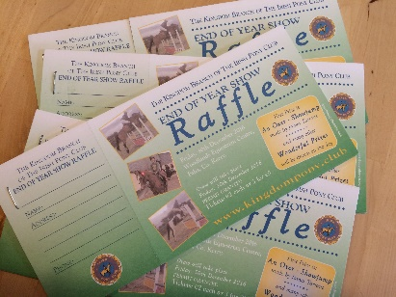

Raffle Prizes 2016

Tickets for sale from The Kingdom branch of Irish Pony Club. Licence obtained.
2 euro for 1 ticket or 5euro for 3 tickets. Tickets available from all members of the branch or from the branch secretary, Una Hayes, at Suttons Oil Ltd, Dromtacker, Tralee, Co. Kerry. Tel: 0872755431.
Draw at our End of Year Show in Woodlands Equestrian Centre on Friday 30th December 2016

- A Show jumping fence made by James Tarrant. The fence is an oxer and includes a filler. Sponsored by John Steadman.
- 2 private coaching session with Bill Maguire Level 2 HSI coach. Each session will drawn individually. Sponsored by Bill Maguire
- A voucher for Equine Athlete supplements. Sponsored by Scott Rawson
- A winter Rug. Sponsored by Rory Sugrue
- A coal bunker. Sponsored by Carbery Plastics
- A dinner for 2 in Leinster House. Sponsored by Senator Mark Daly
- A free tank inspection and boiler service from Mark Greer
- A 50 euros voucher from Suttons Oil Ltd
- A season family pass for 2017 for Derreen Gardens, Lauragh, Kenmare
- A gift voucher for Parknasilla Resort and Spa, Sneem. Sponsored by Tony Daly
- A meat voucher from Ciaran Hartnett butcher.
- 2 bags of horse feed from Boyles patio and Stove centre. To be drawn individually.
